LAB EXPERIMENT RECORD
Set 5: Website Analytics

Department | CSE-Ds
Course Code / Course Name | DSA0601 / Data Handling and Visualization
Experiment | Data Visualization using R
Name | N. Lahari
Register Number | 192473018
Date | 03 October 2026
Day | Saturday

Aim
To visualize website traffic data using a line chart, bar chart, and stacked area chart, and to create an interactive dashboard for exploring website traffic data.
Dataset: Website Traffic
Date | Page Views | Click-through Rate
2023-01-01 | 1500 | 2.3%
2023-01-02 | 1600 | 2.7%
2023-01-03 | 1400 | 2.0%
2023-01-04 | 1650 | 2.4%
2023-01-05 | 1800 | 2.6%

PROGRAM 1: Line Chart of Daily Page Views
Create a line chart to visualize the trend in daily page views over time. Label the axes and title the chart.
date <- as.Date(c("2023-01-01", "2023-01-02", "2023-01-03",
"2023-01-04", "2023-01-05"))

page_views <- c(1500, 1600, 1400, 1650, 1800)
plot(date, page_views,
type = "o",
xlab = "Date",
ylab = "Page Views",
main = "Daily Website Page Views",
col = "blue")
Output 1: Daily Website Page Views Line Chart
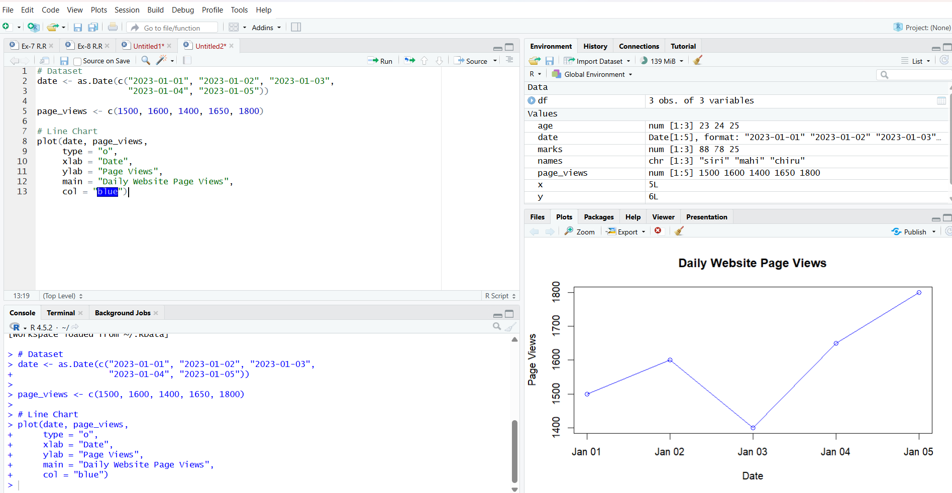
Observation
The line chart shows the daily trend in website page views. Page views increase from 1500 on January 1 to 1600 on January 2, decrease to 1400 on January 3, and then increase to the highest value of 1800 on January 5.
PROGRAM 2: Bar Chart of Top N Click-through Rates
Generate a bar chart showing the top N days with the highest click-through rates. Label the chart elements.
date <- c("2023-01-01", "2023-01-02", "2023-01-03",
"2023-01-04", "2023-01-05")
ctr <- c(2.3, 2.7, 2.0, 2.4, 2.6)
website <- data.frame(date, ctr)
# Sort by click-through rate
website <- website[order(-website$ctr), ]

top_n <- head(website, 3)
barplot(top_n$ctr,
names.arg = top_n$date,
xlab = "Date",
ylab = "Click-through Rate (%)",
main = "Top 3 Days by Click-through Rate",
col = "skyblue")
Output 2: Top 3 Days by Click-through Rate Bar Chart
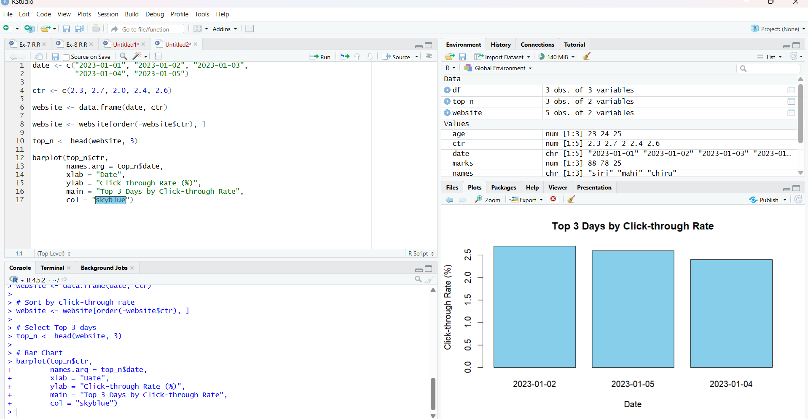
Observation
The bar chart compares the three days having the highest click-through rates. January 2 has the highest click-through rate of 2.7%, followed by January 5 with 2.6%, and January 4 with 2.4%.
PROGRAM 3: Stacked Area Chart of User Interactions
Develop a stacked area chart to display the distribution of user interactions such as likes, shares, and comments on a website.
date <- as.Date(c("2023-01-01", "2023-01-02", "2023-01-03",
"2023-01-04", "2023-01-05"))

likes <- c(L1, L2, L3, L4, L5)
shares <- c(S1, S2, S3, S4, S5)
comments <- c(C1, C2, C3, C4, C5)
interactions <- rbind(likes, shares, comments)
matplot(date, t(interactions),
type = "l",
lty = 1,
lwd = 2,
xlab = "Date",
ylab = "Number of Interactions",
main = "Website User Interactions")
legend("topleft",
legend = c("Likes", "Shares", "Comments"),
lty = 1,
lwd = 2)
Output 3: Website User Interactions Stacked Area Chart
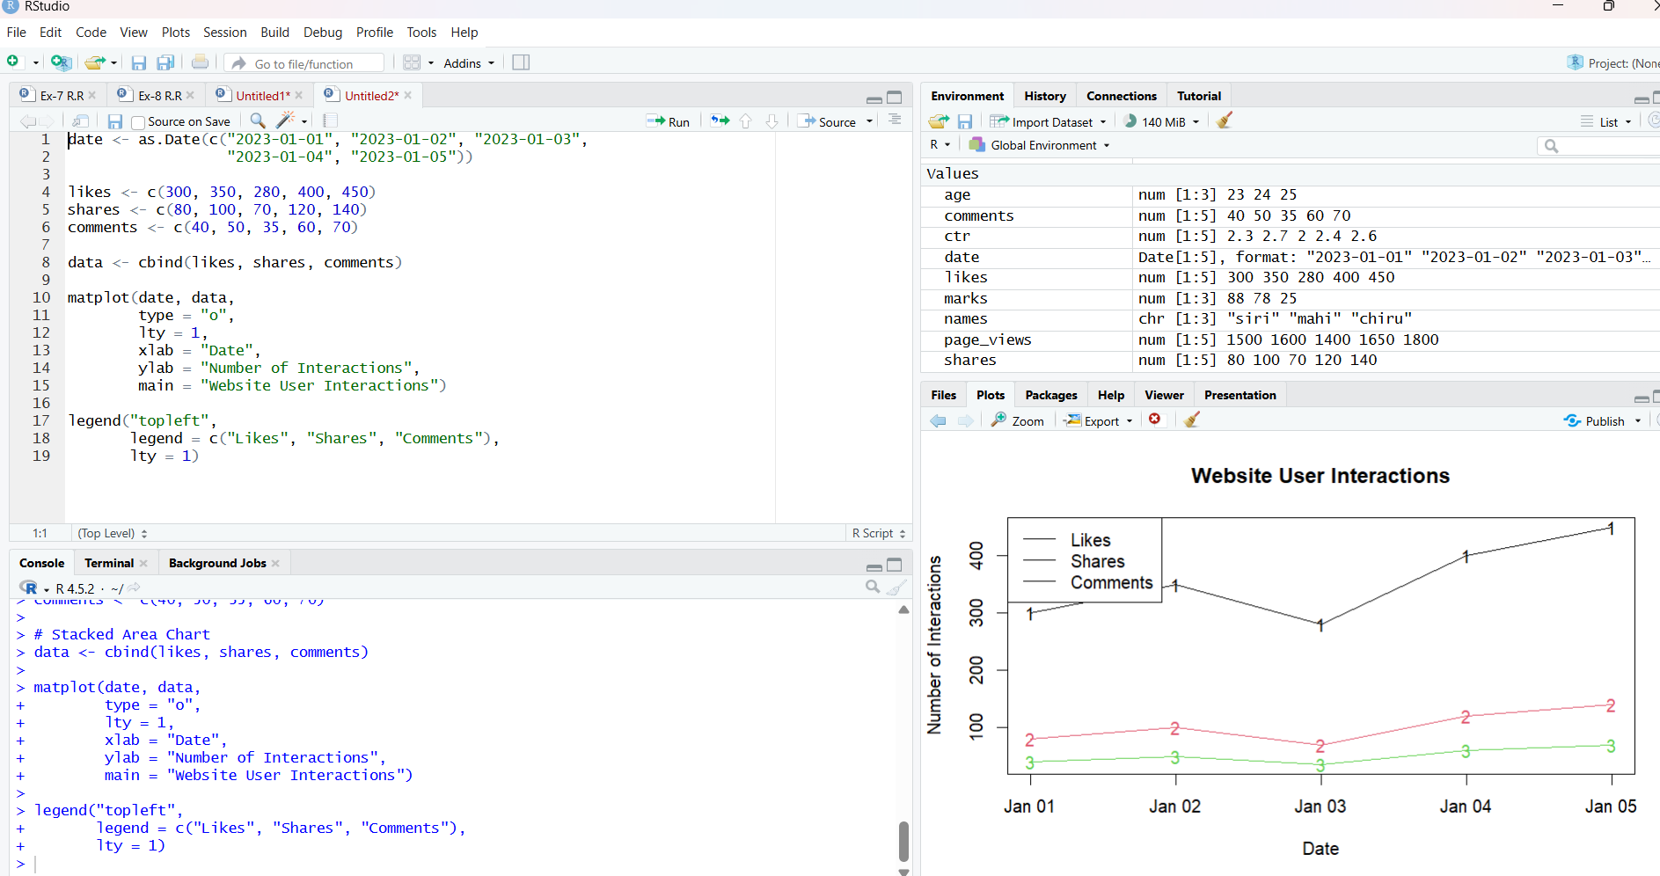
Observation
The stacked area chart represents the distribution of user interactions over time. It allows comparison of the number of likes, shares, and comments for each date.
Note: Actual Likes, Shares, and Comments values are required to generate the final chart because they are not included in the supplied Set 5 dataset.
PROGRAM 4: Interactive Website Traffic Dashboard
Build a dashboard containing the line chart and bar chart for interactive exploration of website traffic data.
Data
Date Page Views Click-through Rate
2023-01-01 1500 2.3
2023-01-02 1600 2.7
2023-01-03 1400 2.0
2023-01-04 1650 2.4

Output 4: Interactive Website Traffic Dashboard
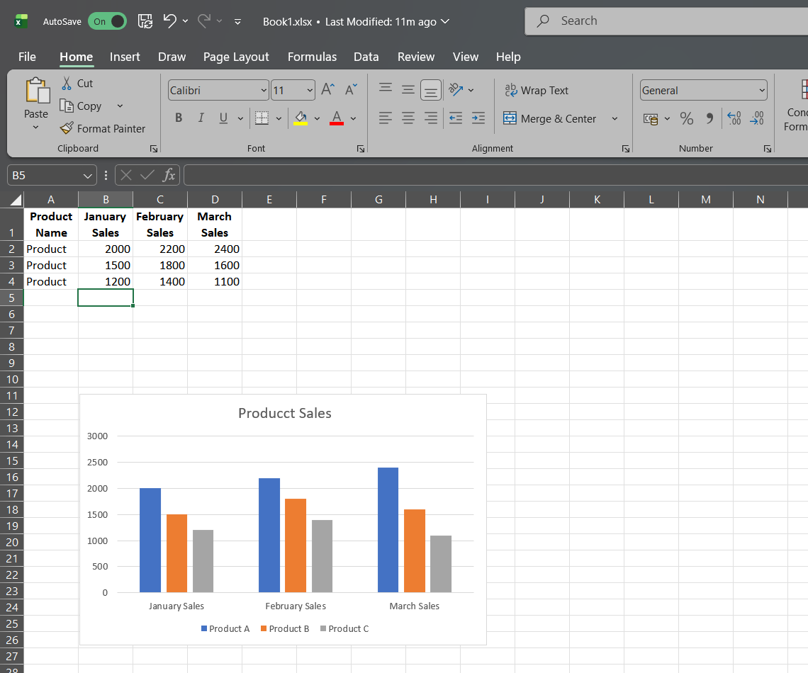
Create an Excel file with the following columns:
Product ID | Product Name | January Sales | February Sales | March Sales
1 | Product A | 2000 | 2200 | 2400
2 | Product B | 1500 | 1800 | 1600
3 | Product C | 1200 | 1400 | 1100

